BENGALS BY ROSIE ALGER-STREET

The story of Bengals in the UK began in 1991 and Typhast Bengals were amongst the first to enter the country during that year. The breed has come a long way since those early days and this is entirely due to the vision, dedication and years of hard work by Bengal breeders all over the world. In the early days breeders would be heard saying “One day we will be able to produce doughnut rosettes” and “ one day we will be able to produce white tummies”, and now , thanks to all that work we are seeing those features increasingly in the Bengals of today.
Our own breeding has always been based on Health, Type and Temperament and when we have seen the need to introduce new features or strengthen our existing lines we have always tried to do so by introducing the best cats available. There is no such thing as the perfect Bengal, but if the current rate of progress continues who is to say where the breed will be in a few years time.
Our own lines have now reached the stage where all of our breeding Bengals are rosetted and with the introduction of Wizard, our first really white-tummied stud, we were able to introduce this feature into our lines.
We have now progressed three generations down from Wizard, and using queens that already carried the white-tummied gene, we are starting to get some really positive results from Wizard's son "Dune".
This breed has brought like minded people together all over the world and many of us have friends we would never have met but for our mutual love of this addictive breed. In our case the list is very long but we would like to mention one special friend and that is Gene Ducote, of Gogees Bengals. Over the years Gene has helped us secure many of the cats we have needed to progress the breed in the UK and for that we owe her a very big thank you.
THE BENGAL CAT
by Rosie Alger-Street
Wellbeloved Pet Club Magazine, Issue Number Seven

Typhast Treasurechest (F3)  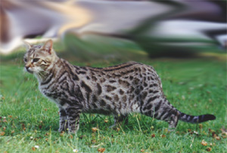 | THE ORIGINS OF THE BREED  The Bengal cat originated as a cross between an Asian Leopard Cat (Felis bengalensis) and a domestic cat (Felis dometicus). In the early 1980s American paediatrician Dr. Centerwall had been researching feline leukaemia. He discovered that the Asian Leopard cat was naturally immune to leukaemia, so crossed it with a domestic cat to see whether this immunity could be bred into ordinary domestic cats. Unfortunately there was very little evidence of this and, with the advent of FeLV Vaccines the project was shelved. The founder of the breed, Jean Mill, took on the resultant hybrids and they have since progressed to the beautiful cats they are today.

WILD LOOKS  The Bengal is a "wild" looking domestic cat with a conformation definitely reminiscent of its wild ancestors. The standard calls for a large, sleek, very muscular domestic cat with its hindquarters slightly higher than its shoulders and a thick tail that is carried low. The Bengal's head is rounded and is slightly longer than it is wide. The nose is broad, the muzzle full, with a light coloured, strong rounded chin and pronounced whisker pads created by the wide-set canine teeth. The ears are medium to small with rounded tips, pointing forward in profile. The eyes are slightly almond shaped. They are large, but not bold and set on a slight slant toward the base of the ear.  Its distinctive spotted or marbled tabby coat enhances the Bengal's wild appearance, and should be thick and luxurious. Colours and markings include Black or Brown Spotted, Black and Gold or Brown Marbled, as well as Snow Spotted and Snow Marbled. There is no other breed that displays the gold or pearl dusting effect (glitter) of the Bengal. The texture of the coat is unique. It has the feel of satin or silk with a touch sensation that is unequalled in any other breed of cat. More recently, the Silver Gene has been introduced and we now have the added bonus of Silver Spotted and Silver Marbled Bengals. (with diamond glitter). | Typhast Mekla  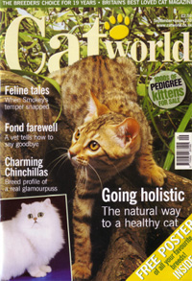

Typhast Virtual Reality (F5)  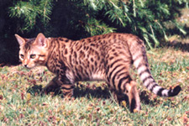 | GOOD TEMPERAMENT  The Asian Leopard Cat is a very beautiful, but naturally shy, nocturnal animal, and therefore was an ideal choice to mix with the domestic cat. Having borrowed the "wild look" from nature, there was little that needed to be done about appearance, so the original American breeders concentrated on temperament, using the sweetest natured cats for their outcrosses and successive generations.

The press has propagated the myth that a Bengal is a "wild cat". But in reality it has a more balanced character than many existing pedigree cats who have been bred only for type and so their temperament has suffered. The Bengals have been bred for temperament - and it shows! The result is a delightful animal, looking like a little leopard on the outside but behaving like an intelligent, loving hooligan and a full member of the family.  Bengals have a great sense of humour and do not like to be ignored. They mix very well with other animals, particularly dogs, with which they seem to have a great empathy. | 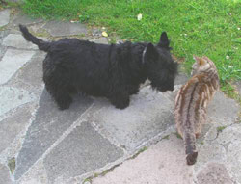

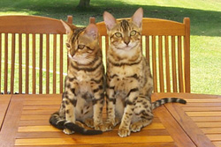 | They gravitate towards small children and make excellent companions, joining in all the games. They have a fascination for water and don't seem to mind the rain. When drinking they will clear the bowl with their paws first, as though clearing a stream. Owners are advised to keep toilet seats closed and be prepared for company in the shower! Drinking from a running tap seems to be a common practice amongst Bengals. We have in fact bought a filtered water fountain for them which has proved to be very popular. Bengals do need company, so it is recommended to have two cats if there is no-one at home during the day.
Generally, the Bengal is like any regular pedigree domestic cat and needs no special feeding and will do well on a good quality diet such as James Wellbeloved. They do not need to go outside providing they have plenty of stimulation indoors. They make brilliant retrievers and will play for hours bringing back a thrown toy.

